INTELLIGENT TRAFFIC SIGNAL CONTROLLER
With Pedestrian Input and Emergency Override
A Project Based Learning Report Submitted in partial fulfilment of the requirements
for the award of the degree of
Bachelor of Technology
in the Department of Artificial Intelligence and Data Science
Embedded Systems Design (ESD) & Internet of Things
Course code: 25EC2206E
Submitted by
2510080001 — Yeshwanth
2510080012 — M. Sai Vignesh
2510080054 — Krithik Reddy
2510080011 — Srujan Reddy
2510080056 — Ruthvik Yerram
2510080022 — Niharika
2510080049 — Tejaswini
Under the guidance of
Dr. Botsa Kishore Kumar


Department of Artificial Intelligence and Data Science
Koneru Lakshmaiah Education Foundation, Aziz Nagar
Aziz Nagar – 500075

ABSTRACT
This Project Based Learning work addresses the design of an intelligent traffic signal controller using an STM32 microcontroller. The academic problem calls for a timed three-light sequence, pedestrian input, vehicle detection by an infrared sensor, an emergency relay output, prioritized interrupts, and UART state communication. The project is therefore a compact case study in general-purpose input/output (GPIO), timers, external interrupts (EXTI), the Nested Vectored Interrupt Controller (NVIC), peripheral integration, and event-driven embedded firmware.
The photographic evidence supplied by the team shows a breadboard prototype connected to an ST Nucleo development board, LED indicators, relay modules, and a sensor board. The board silkscreen visible in the photographs identifies the hardware as NUCLEO-F103RB. Two later photographs show different illuminated signal indicators, giving visual evidence that LED outputs were powered during the experiment. Photographs alone do not establish exact timing accuracy, input debouncing, interrupt priority order, UART messages, or successful emergency preemption. Those items are documented as design requirements and validation steps rather than completed measurements.
A finite-state-machine approach is proposed with the academic timing targets RED = 5 s, GREEN = 5 s, and YELLOW = 2 s. On the photographed STM32F103RB, TIM2 is an appropriate candidate for the periodic interrupt tick; the earlier suggestion of TIM6 must not be used for this device because the medium-density STM32F103RB does not provide that peripheral. Interrupt service routines record events and the main control logic applies safe transitions, with emergency requests handled ahead of normal timing and pedestrian requests.
The methodology combines system block diagrams, state-transition analysis, timer calculations, interface descriptions, pseudocode, photo documentation, structured tests, and a requirements traceability matrix. The result is an implementable teaching prototype architecture, accompanied by a transparent distinction between observed evidence, proposed behavior, and work still requiring bench verification.
Keywords: STM32F103RB, NUCLEO-F103RB, traffic signal, GPIO, TIM2, EXTI, NVIC, UART, IR sensor, relay, finite-state machine.

LIST OF FIGURES
01 Functional architecture of the proposed traffic-signal controller .................................... 9
02 Logical connection concept; GPIO pin numbers are not yet verified .................................... 11
03 Proposed finite-state machine, including pedestrian and emergency conditions .................................... 12
04 Expected signal schedule for two nominal 12-second cycles (not measured) .................................... 13
05 Event-driven main control loop and emergency decision path .................................... 18
06 Proposed priority ordering and short-ISR event collection .................................... 19
07 Original team photograph: NUCLEO-F103RB, breadboard, relay boards and sensor module (23 Aug 2026, 03:52) .................................... 22
08 Original team photograph: close perspective of initial breadboard wiring and relay/sensor modules (23 Aug 2026, 03:52) .................................... 23
09 Original team photograph: illuminated red breadboard LED with powered STM32 board and relay-module indicator (23 Aug 2026, 05:25) .................................... 24
10 Original team photograph: illuminated green breadboard LED and powered prototype (23 Aug 2026, 05:25) .................................... 25
11 Suggested staged verification sequence for the complete demonstrator .................................... 26
12 Phased roadmap from verified GPIO operation to a validated integrated controller .................................... 35

LIST OF TABLES
01 Requirements-to-evidence map .................................... 8
02 Prototype bill of materials and evidence classification .................................... 10
03 Reference transition policy; pedestrian dwell time remains configurable .................................... 12
04 Nominal timing parameters; design targets, not bench measurements .................................... 13
05 Pedestrian-request acceptance and safety tests .................................... 14
06 Emergency override operating policy .................................... 15
07 Suggested repeatable IR sensor tests .................................... 16
08 Illustrative output messages; not a captured serial log .................................... 17
09 Proposed NVIC order; confirm priority grouping in CubeMX .................................... 19
10 Pin assignment worksheet intentionally awaiting source project evidence .................................... 21
11 Red-state test evidence and outstanding timing proof .................................... 24
12 Pedestrian and interrupt-priority test matrix; results pending .................................... 27
13 IR, relay, UART and integrated experimental checklist .................................... 28
14 Representative failure modes and corrective actions .................................... 29
15 Observed evidence separated from unverified system functions .................................... 30
16 Predicted transition schedule without exceptional events .................................... 31
17 Faculty-task verification and honest status report .................................... 32

The tables separate prescribed targets and proposed procedures from bench-tested results. Where measured evidence is unavailable, entries are marked “not supplied” or “verification pending”.

TABLE OF CONTENTS
ABSTRACT 2
LIST OF FIGURES 3
LIST OF TABLES 4
1. INTRODUCTION 6–8
2. METHODOLOGY 9–21
3. EXPERIMENTS 22–29
4. RESULTS 30–33
5. CONCLUSION AND FUTURE WORK 34–35
REFERENCES 36

INTELLIGENT TRAFFIC SIGNAL CONTROLLER
CHAPTER 1
1. INTRODUCTION — PROBLEM CONTEXT

1.1 Background
Signalized road intersections are familiar examples of real-time control systems. Different movements compete for the same physical space, so a controller must enforce mutually exclusive permission, allocate the right-of-way, and respond to special requests without creating an unsafe conflict. For an embedded-systems laboratory, a three-colour signal is especially useful because it converts invisible software logic into an observable electrical output. Each LED has a defined meaning; every state transition can be checked against a timing diagram; and requests from switches or sensors introduce the idea of event-driven behavior.
A conventional software-delay demonstration may illuminate red, green, and yellow LEDs in a fixed order. Although simple to write, such a program can ignore important inputs while it waits. Pedestrian requests may be missed, emergency events may be delayed, and sensor monitoring becomes difficult. Using a hardware timer, external interrupts, and a state machine instead separates elapsed-time measurement from application decisions. The timer produces regular ticks, interrupts capture time-sensitive events, and the main logic chooses the next safe action.

1.2 Motivation for the assigned problem
The provided hackathon task explicitly combines eight embedded concepts: GPIO configuration, a timer-driven traffic sequence, push-button input and EXTI, IR-based vehicle sensing, relay-based emergency signaling, NVIC priorities, UART communication, and an explanation of nonblocking design. By integrating these topics into one demonstrator, the team can relate microcontroller peripherals to system requirements. The output LEDs make correctness visible; the optional serial interface gives a textual diagnostic view; and the emergency path exposes the importance of priority and fail-safe behavior.

1.3 Engineering objective
The objective is to design a prototype controller whose outputs never intentionally command conflicting traffic permissions; whose nominal three-colour cycle follows programmed dwell times; whose pedestrian request is stored until a safe opportunity; and whose emergency condition can interrupt the normal sequence. It is a learning prototype, not a certified road-traffic controller. The hardware photographed for this report must be treated as a bench demonstrator with limited sensing, power protection, and redundancy.

CHAPTER 1
1. INTRODUCTION — OBJECTIVES AND SCOPE

1.4 Specific objectives
1. Set three dedicated GPIO output lines for red, yellow, and green traffic indicators, with current-limiting components.
2. Implement normal RED → GREEN → YELLOW → RED transitions through an explicit state machine and a hardware-generated periodic tick.
3. Configure a pedestrian push button as a digital input and latch a rising or falling-edge request through EXTI/NVIC.
4. Read a digital IR module to model vehicle presence; use the reading without creating an unsafe abrupt green transition.
5. Use a relay module as a demonstration emergency output, subject to module power and logic-level compatibility.
6. Allocate interrupt preemption priorities, send readable status over UART, and collect repeatable test evidence.

1.5 Functional and nonfunctional boundaries
The design deliberately limits the physical signal model to one group of three LEDs. A real intersection would have separate lamp heads for orthogonal roads, conflict zones, pedestrian walk/don’t-walk indicators, and independently verified fail-safe outputs. In this prototype, the words “pedestrian phase” refer to a software interval or status that may not yet have a dedicated pedestrian lamp. Similarly, “emergency override” refers to a simulated condition recognized by firmware, not a roadworthy preemption mechanism.
Nonfunctional goals are as important as functional behavior. The firmware should avoid blocking delays, make interrupt handlers short, preserve explicit output invariants, recover deterministically after a reset, and log transitions in a human-readable form. The design must also be reproducible: a new student should be able to inspect the required connections, build the board-specific project, and reproduce the intended test sequence without relying on unexplained settings.

1.6 Working assumptions
The proposed baseline uses active-high LEDs, a button input with a pull-up and active-low press, an available TIM2 update interrupt, and a simple digital IR detector. These are design assumptions, not independently verified descriptions of each wire in the photographs. The exact connector locations and programmed GPIO pins must be confirmed by comparing the CubeMX .ioc file with the assembled hardware before a final circuit schematic is claimed.

CHAPTER 1
1. INTRODUCTION — TASK TRACEABILITY

1.7 Mapping the assigned tasks to implementation evidence
Assigned requirement | Proposed artifact / proof | Status in supplied material
1. Configure three LED GPIOs | Pin plan + independent LED test | Photo evidence: illuminated red/green indicators
2. Timer-based state machine | TIM2 configuration + transition trace | Design described; timing trace not supplied
3. Pedestrian push button | GPIO pull-up and EXTI line | Button hardware visible; interrupt test pending
4. EXTI and NVIC | ISR event flag + test log | Priority test evidence not supplied
5. IR vehicle sensor | Sensor detection procedure | Module present in early prototype photos
6. Emergency relay | Relay safe output + event matrix | Relay modules photographed; actuation not proven
7. UART traffic status | Serial terminal capture | No UART log supplied
8. Explain timers vs delay | Timing discussion + comparison | Included in methodology and results

Table 1. Requirements-to-evidence map

1.8 Definition of a valid experimental claim
A photograph can show that a device was assembled and powered and that a particular LED was illuminated at the time of capture. It cannot determine how the firmware reached that state, which interrupt fired, whether a timer was configured, or the accuracy of the programmed duration. A serial log documents event messages but requires timestamp context for quantitative timing. A logic-analyzer trace or a verified oscilloscope capture is preferable when substantiating dwell times and priority response latency.
Accordingly, this report labels its evidence carefully: “observed” means directly visible in the supplied images; “specified” means required by the hackathon problem; “proposed” refers to a recommended implementation; and “pending” identifies functionality for which a measurement or screenshot still needs to be attached. This distinction protects the credibility of the final submission while giving a practical checklist for completing it.

CHAPTER 2
2. METHODOLOGY — SYSTEM ARCHITECTURE

2.1 High-level block diagram
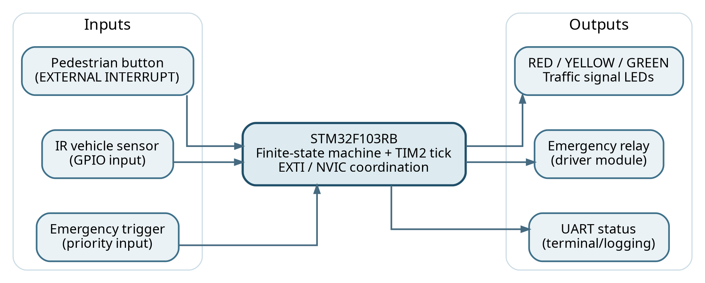
Figure 1. Functional architecture of the proposed traffic-signal controller
The proposed controller uses the STM32F103RB as the central decision-making unit. Digital inputs provide pedestrian, emergency, and IR detection events; a hardware timer provides a stable periodic reference; and output functions drive the traffic indicators, emergency relay, and UART messages. The outputs are logically distinct even if a single board performs all functions. This separation makes interfaces easier to test and makes it possible to add sensing later without rewriting the signal-control core.

2.2 Division into firmware layers
At the lowest level, board support configures clocks, GPIO modes, interrupts, the timer, and serial settings. The event layer converts raw edge and tick events into flags or counters. The control layer runs a deterministic state machine, decides whether a pedestrian request should be served, and treats emergency input as the highest-priority condition. The presentation layer writes signals and emits status messages. Such layering discourages performing slow tasks inside interrupt service routines and reduces the chance of hard-to-debug event races.
Documentation note — Architecture is proposed from the provided problem statement. The photography independently verifies a board, LEDs, wires, relay modules, and an IR-like sensor module; it does not verify all software paths.

CHAPTER 2
2. METHODOLOGY — HARDWARE PLATFORM

2.3 Microcontroller selection and identification
The board marking in the supplied prototype photographs reads NUCLEO-F103RB / MB1136, an ST Nucleo-64 development board built around an STM32F103RB microcontroller. It exposes GPIO on Arduino-compatible and Morpho headers and includes an on-board ST-LINK programmer/debugger. These features are suitable for a teaching demonstration because firmware can be flashed and debugged over USB while the breadboard hosts the signal and input circuits. The board must be selected as STM32F103RB in the development environment so generated drivers and interrupt names match the chip.
An earlier planning note mentioned STM32H743ZI. That designation does not match the photographed board. The distinction is technically consequential: STM32 device families differ in peripheral availability, clock trees, voltage constraints, and initialization code. On the medium-density F103RB, use TIM2, TIM3, or TIM4 for the desired general-purpose periodic interrupt. TIM6 is absent, so a TIM6-specific tutorial cannot be copied unchanged. The project should record the specific NUCLEO-F103RB board revision from the reverse-side sticker if a formal bill of materials is required.

2.4 Inventory visible or specified
Component | Role | Evidence / caution
NUCLEO-F103RB | GPIO, timing, state control | Board marking visible in photographs
Breadboard and jumpers | Rapid, reversible prototype wiring | Visible; continuity still needs checking
Discrete LEDs + resistors | Traffic indications | LED lighting and resistors visible
Push button | Pedestrian demand input | Small switch visible; GPIO connection unverified
Relay modules | Simulated emergency output | Several blue relay modules visible
IR sensing module | Vehicle detection input | Optical sensor module visible
USB cable | Board power / ST-LINK | Visible; current rating must be respected

Table 2. Prototype bill of materials and evidence classification

CHAPTER 2
2. METHODOLOGY — GPIO AND CIRCUIT SAFETY

2.5 GPIO output arrangement
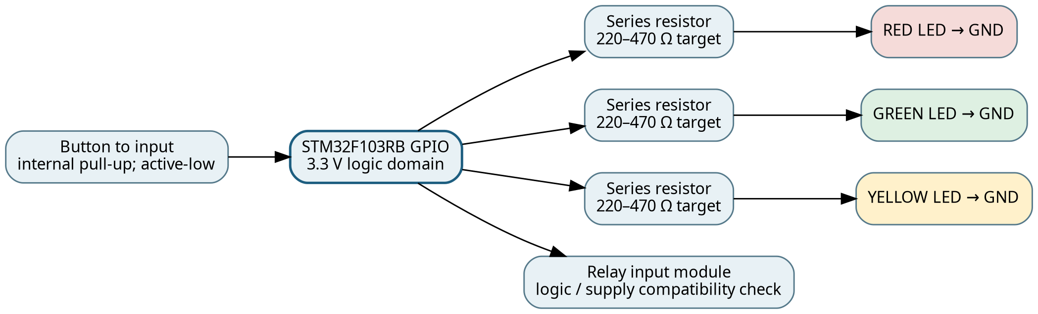
Figure 2. Logical connection concept; GPIO pin numbers are not yet verified
Each traffic LED should be wired through a dedicated current-limiting resistor before it reaches a microcontroller output. With a 3.3 V signal and a representative 2 V red LED, a 330 Ω resistor gives an approximate idealized current of (3.3 − 2.0)/330 ≈ 3.9 mA. LED forward voltage varies by colour and part number, so this calculation is a design example rather than a measured current. Output drive limits and total port current must be checked against the device datasheet. A green or yellow indicator may need a different resistor value to achieve a comparable brightness.

2.6 Safe startup and lamp interlocking
Firmware should initialize the output control bits to a known safe combination before entering the normal cycle. All-red is a useful logical default because it prevents the controller from unintentionally granting traffic permission while other peripherals initialize. A helper routine should clear or set the three LED outputs as one state change, avoiding intermediate software combinations such as simultaneous red and green. The breadboard photograph shows LEDs and discrete resistors, but it is not sufficiently clear to certify individual pin numbering or series connection values.

2.7 Input and relay electrical precautions
An input button must never float. Using an internal pull-up with a normally open switch to ground is one typical arrangement; another is an external resistor network. A relay coil should not be wired directly to a GPIO. A relay module with the appropriate transistor driver, flyback protection, supply arrangement, and control voltage is required. Some off-the-shelf relay boards are 5 V active-low devices; their trigger thresholds cannot be assumed compatible with a 3.3 V STM32 output. Only a low-voltage demonstration load is appropriate unless qualified supervision and isolation are provided.

CHAPTER 2
2. METHODOLOGY — FINITE-STATE MACHINE

2.8 State representation
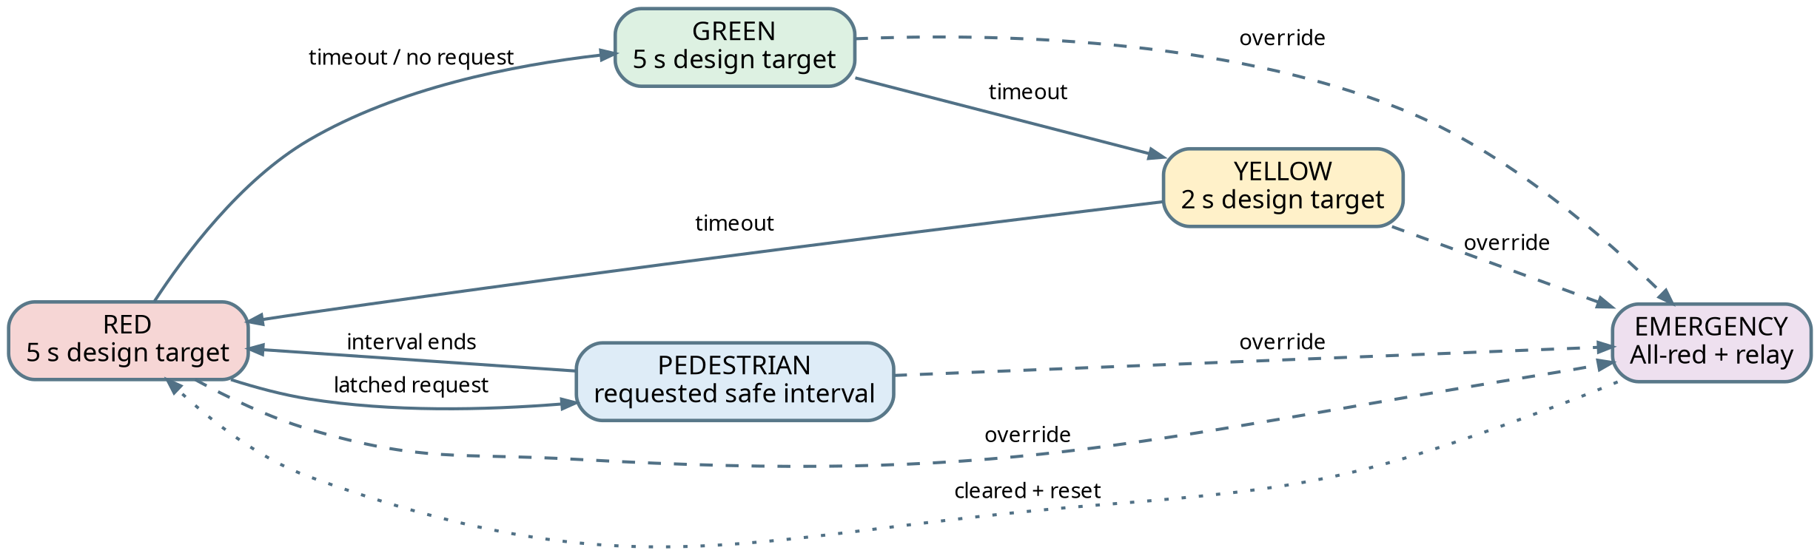
Figure 3. Proposed finite-state machine, including pedestrian and emergency conditions
The controller is represented by a finite set of mutually exclusive software states. During normal service, it cycles through RED for five seconds, GREEN for five seconds, and YELLOW for two seconds. An elapsed-time counter is reset when a new state is entered, and output pins are driven from the active state rather than from loosely synchronized boolean variables. This prevents time-control logic and lamp-control logic from drifting apart.

2.9 Pedestrian and emergency handling rules
A pedestrian press latches a request, which is serviced at a safe RED boundary. If an explicit pedestrian interval is implemented, its duration must be configured and a suitable indication supplied; the photographs do not demonstrate a dedicated pedestrian LED. An emergency request interrupts the normal plan and forces a defined fail-safe output pattern, proposed here as all-red with the relay active. When the request clears, returning to RED before resuming the cycle avoids restoring a stale GREEN permission. These rules are design choices that must be tested against the faculty’s specific interpretation of emergency signaling.
Present state | Condition | Next state | Output policy
RED | 5 s, no ped request | GREEN | Green ON only
GREEN | 5 s elapsed | YELLOW | Yellow ON only
YELLOW | 2 s elapsed | RED | Red ON only
RED | Pending pedestrian | PEDESTRIAN | All-red; interval to confirm
ANY | Emergency asserted | EMERGENCY | All-red; relay control asserted
EMERGENCY | Emergency cleared | RED | Relay reset; restart safely

Table 3. Reference transition policy; pedestrian dwell time remains configurable

CHAPTER 2
2. METHODOLOGY — TIMER INTERRUPTS

2.10 Deriving a periodic timer tick
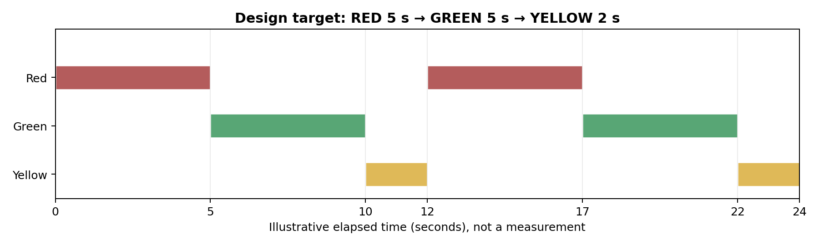
Figure 4. Expected signal schedule for two nominal 12-second cycles (not measured)
A general-purpose timer counts input clock pulses through a prescaler (PSC) and reloads after the auto-reload register (ARR) limit. For an up-counting STM32 timer, the nominal update-event frequency is f_update = f_timer / [(PSC + 1)(ARR + 1)]. If the timer input is verified as 72 MHz, PSC = 7199 and ARR = 9 produce 72,000,000 / (7200 × 10) = 1000 updates per second, equivalent to a 1 ms tick. The actual timer clock must be derived from RCC/APB prescalers because an STM32 APB timer clock can differ from its bus peripheral clock when the APB prescaler is greater than one.

2.11 TIM2 rather than TIM6 on the photographed board
The STM32F103RB contains general-purpose timers TIM2, TIM3, and TIM4, alongside TIM1, but not TIM6. Therefore, CubeMX/CubeIDE should be configured for TIM2 → Internal Clock → Prescaler / Counter Period → Update Interrupt → NVIC enable. The appropriate peripheral initialization and HAL_TIM_Base_Start_IT call must correspond to htim2, and the generated interrupt handler should invoke HAL_TIM_IRQHandler. The period-elapsed callback can update a volatile tick flag or counter. GPIO updates and expensive serial transmission are preferably performed in main-context event processing rather than inside this callback.

2.12 Timing method and mathematical targets
State | Target duration | 1 ms ticks | What should be verified
RED | 5 s | 5,000 | Measured time between rising transitions
GREEN | 5 s | 5,000 | Measured hold time and mutual exclusion
YELLOW | 2 s | 2,000 | Measured clearance duration
Entire cycle | 12 s | 12,000 | Cycle period without special requests

Table 4. Nominal timing parameters; design targets, not bench measurements

CHAPTER 2
2. METHODOLOGY — PEDESTRIAN INPUT

2.13 Configuring the push button
A pedestrian input gives the controller an asynchronous external event. A proposed circuit connects a normally open push button between a 3.3 V logic input and ground with an enabled internal pull-up, giving idle logic 1 and active logic 0. In CubeMX the selected GPIO can be configured as an external interrupt on the falling edge. After enabling the corresponding EXTI line in NVIC, pressing the switch should cause the ISR callback to register a request. This is not equivalent to stopping the controller immediately; the application still determines the safe point at which a pedestrian interval begins.

2.14 Latching, debounce, and service policy
Mechanical push buttons bounce for a few milliseconds, potentially creating multiple edges. A software debounce policy can record the most recent accepted press timestamp and ignore duplicate edges in a short window, such as 30–50 ms. This interval is an engineering example to be tuned for the chosen switch. The interrupt routine should be short: it sets a pending flag and returns. The main loop reads the flag and queues a pedestrian phase for the next RED boundary. Clearing a request before it has been served would create missed events, so the request should be reset only after explicit acknowledgement by the state machine.

2.15 Pedestrian safety invariant
A pedestrian phase must never turn on a traffic GREEN lamp at the same time that people are permitted to cross the same path. In the demonstration, a conservative rule is “pedestrian service implies traffic all-red.” If a pedestrian lamp is absent, the controller should at least log the phase via UART or visibly indicate it through an additional test output before claiming the pedestrian crossing feature is complete.
Scenario | Expected software response | Required proof
Press during GREEN | Latch, defer until safe RED | ISR event timestamp and deferred service log
Press during RED | Start permitted crossing policy | Output state capture
Multiple bounces | One accepted request | Button event count under repeated press
Emergency while requested | Emergency takes precedence | Priority and post-emergency recovery trace

Table 5. Pedestrian-request acceptance and safety tests

CHAPTER 2
2. METHODOLOGY — EMERGENCY OVERRIDE

2.16 Meaning of emergency override
Emergency operation is an exceptional mode that is allowed to preempt the ordinary timing sequence. Its exact lamp pattern is not dictated by the student’s summary beyond the instruction to control a relay representing an emergency signal. For safe prototyping, the report recommends all-red traffic outputs and a separately commanded relay module. This representation is intended to be visually and electrically testable on the bench; it is not a field deployment protocol for emergency vehicles or public roads.

2.17 Relay interface
A relay provides an electromechanical switch controlled by an isolated driver circuit on the module, but the relay module itself still requires appropriate supply power and safe logic signaling. First identify its VCC, GND, and IN pins from the exact manufacturer marking; verify whether its trigger is active-high or active-low; and do not infer the relay contact state from a power indicator LED alone. If the physical load is connected to COM and NO, the default unenergized condition is open; connecting a load to NC has the opposite default. The user must choose a safe low-voltage load and record both the energized condition and logic command polarity.

2.18 Preemption, persistence, and return
When emergency mode is asserted, the state machine should save the request type, command the selected safe output state, and signal the relay. In the proposed design, normal dwell-time progression is suspended or disregarded while emergency mode remains active. Once the emergency trigger clears, the controller restarts from RED and a full red dwell period. If the trigger is noisy, suitable debounce or a minimum hold interval may be necessary. The system should also define what happens if the relay supply is unavailable: firmware ought to retain a safe traffic LED pattern even if relay actuation cannot be guaranteed.
Condition | Normal sequence | Relay | Traffic lamps
No emergency | Enabled | Inactive | Exactly one normal colour
Emergency asserted | Suspended | Asserted | All-red proposed
Emergency released | Restart from RED | Inactive | RED before GREEN
Lost relay power | Controller remains active if supplied | Unavailable | Fallback red; report fault

Table 6. Emergency override operating policy

CHAPTER 2
2. METHODOLOGY — IR VEHICLE DETECTION

2.19 Purpose of vehicle sensing
An infrared reflective sensor is a simple vehicle-presence input for the bench prototype. Typical modules include an IR emitting element, a photodetector, and threshold electronics producing a digital output. Placing an object within an appropriate sensing distance can change the output state, which firmware interprets as “vehicle present” or “vehicle absent.” The exact detection polarity, working distance, sunlight sensitivity, and operating voltage must be determined from the installed module, not assumed from its shape.

2.20 Interface strategy
For the basic task, sample the digital sensor pin at a stable point in the main loop or trigger on an edge and debounce with the same event infrastructure. The input must share a valid logic reference with the microcontroller, and a module powered at 5 V must not drive an STM32 input above its permitted rating unless the particular pin is documented as tolerant and the wiring meets all stated limits. Using a verified 3.3 V-compatible sensor is simpler. Because the faculty task says only “detect vehicle presence,” the controller may first report the presence over UART without changing timing. Adaptive extension logic should only be added after normal timing and emergency priority have been proven.

2.21 Interpreting sensor readings safely
A single low-cost IR sensor cannot measure lane occupancy reliably in every lighting and weather condition. A transition caused by a hand, desk surface, or LED reflection should not be represented as a real traffic count. For a classroom prototype, use a fixed object and a documented distance for repeated tests; record both detection and release time; and treat missed detections as sensor-interface issues to investigate. Any algorithm that extends GREEN on “vehicle present” should specify a maximum green duration and must not bypass a pending emergency request or a required pedestrian interval.
Sensor experiment | Input stimulus | Expected observation
No object | Clear field of view | Stable baseline logic level
Test object present | Object within calibrated range | Changed digital output / serial status
Object removed | Return to no-object state | Detection flag clears
Noisy boundary | Slowly move near threshold | No unsafe light conflict; filter as needed

Table 7. Suggested repeatable IR sensor tests

CHAPTER 2
2. METHODOLOGY — UART COMMUNICATION

2.22 UART as an observability interface
Universal Asynchronous Receiver/Transmitter (UART) communication provides a diagnostic channel for viewing the controller’s internal decisions. A serial terminal can display changes such as “STATE=RED, ELAPSED=0”, “PED_REQUEST=1”, “IR_PRESENT=1”, or “EMERGENCY=ACTIVE”. These are example message formats for the report, not screenshots of actual transmitted data. Such logging is useful during a faculty demonstration because it shows that the controller is processing inputs, not merely switching LEDs at fixed intervals.

2.23 Interface parameters and initialization
A typical lab configuration is 115200 baud, eight data bits, no parity, and one stop bit. This is a proposed setting that must be matched at both ends. The STM32 USART peripheral chosen in the CubeMX project must be checked against the board’s ST-LINK virtual COM routing and any jumpers in the Nucleo board manual. If the selected USART is not routed to the ST-LINK VCP, an external USB-to-UART adapter is needed. Adapter GND must be common with STM32 GND, and UART TX/RX must be crossed appropriately while respecting 3.3 V logic levels.

2.24 Logging without breaking real-time behavior
Blocking serial transfers inside timer or EXTI interrupt callbacks can delay later interrupts, obscure the actual dwell times, and introduce reentrancy hazards. A safer architecture queues short event records in memory and transmits them from the main loop. For a small demonstration, it may be sufficient to send messages only on state changes, not every millisecond. A monotonically increasing tick counter makes traces easier to interpret. If a queue overflows, increment a dropped-message counter rather than letting communication hold the traffic outputs hostage.
Illustrative UART line | Event communicated
T=00000 STATE=RED | Initialization to safe state
T=05000 STATE=GREEN | Nominal red dwell completed
T=10000 STATE=YELLOW | Nominal green dwell completed
T=12000 STATE=RED | Nominal yellow dwell completed
T=xxxxx PED_PENDING=1 | Pedestrian input latched
T=xxxxx EMERGENCY=1 | Priority event requested

Table 8. Illustrative output messages; not a captured serial log

CHAPTER 2
2. METHODOLOGY — CONTROL ALGORITHM

2.25 Integrated nonblocking logic
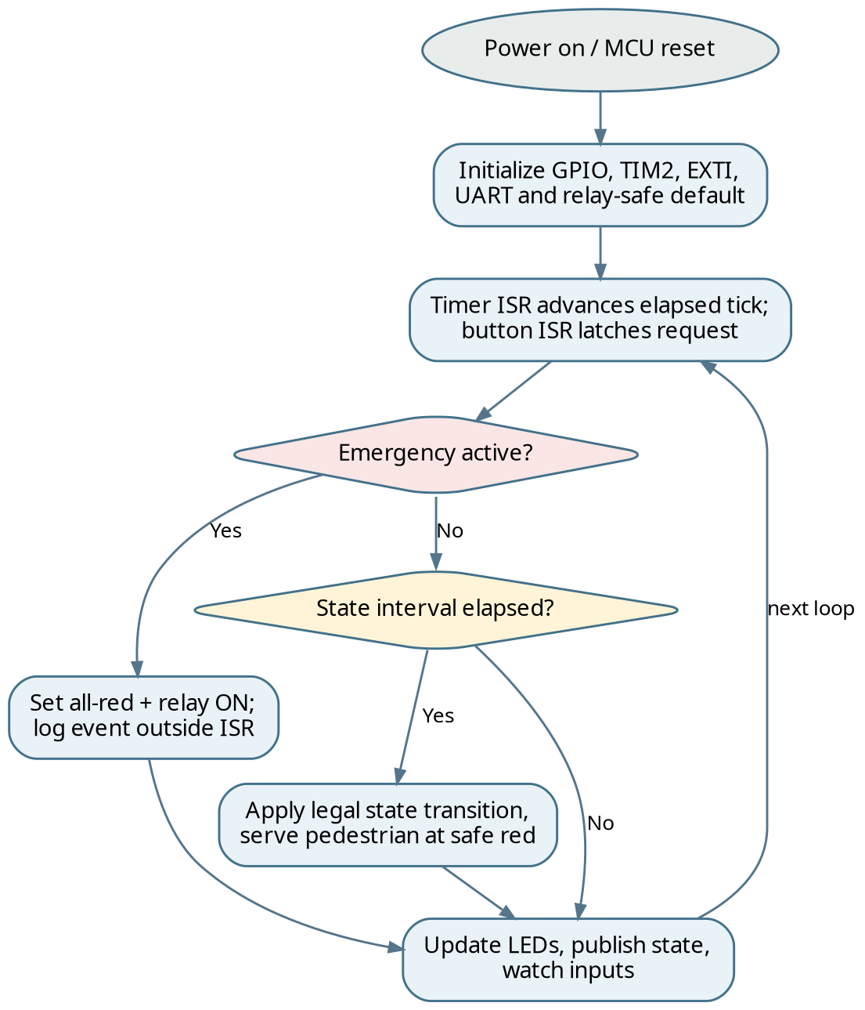
Figure 5. Event-driven main control loop and emergency decision path
The application begins by initializing peripherals and commanding a safe lamp configuration. The timer update callback increments a shared tick count, while external interrupt callbacks set flags associated with pedestrian or emergency triggers. The main loop periodically snapshots these shared variables, evaluates the emergency condition first, determines whether the active state has consumed its allotted duration, processes any pending safe transition, updates GPIO, and publishes a status record.
This design avoids placing the control sequence inside nested delay loops. Timed events are represented as elapsed ticks, not as sleep calls. A pedestrian request that occurs between two ticks can still be recorded promptly by EXTI; a pending emergency can be recognized before an ordinary GREEN command; and UART transmission can be scheduled when a state change occurs. The state machine also defines a single function responsible for changing the lamp outputs, which simplifies reasoning about the “never two conflicting colours” invariant.

2.26 Failure handling
If input state is uninitialized, a timer fails to start, or an unexpected enum value is encountered, software should prefer a predefined red-safe fallback rather than continuing with potentially inconsistent outputs. Watchdog and brownout monitoring can be explored in future work; fault-injection tests must remain low-voltage and supervised.

CHAPTER 2
2. METHODOLOGY — NVIC PRIORITIES

2.27 Prioritized interrupt handling
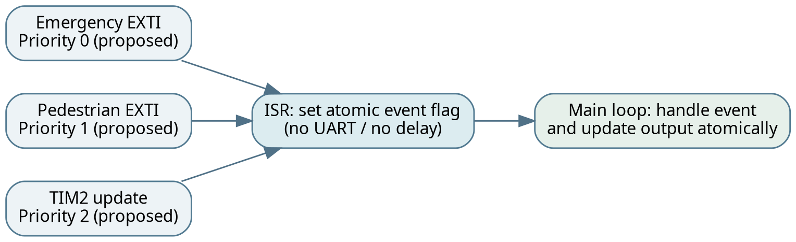
Figure 6. Proposed priority ordering and short-ISR event collection
The Nested Vectored Interrupt Controller controls exception dispatch and preemption. In common Cortex-M priority schemes, a numerically lower priority value means a higher urgency. The proposed relative order is emergency event first, pedestrian button second, and timer tick third. The exact priority grouping and number of implemented priority bits are MCU-dependent and must be verified in the selected STM32 project. Emergency preemption should never be simulated by running a long busy wait inside the interrupt handler; instead, the ISR marks the condition and returns so that the application can enforce the fail-safe lamp output promptly.

2.28 Race conditions and sharing data
An event flag written in an interrupt callback and read in main context should be declared and accessed in a way consistent with the compiler and CPU memory model. Volatile prevents certain compiler caching of a memory-mapped or ISR-shared flag but is not a complete concurrency primitive for complex operations. On a 32-bit Cortex-M, naturally aligned 32-bit loads/stores are generally atomic, but compound operations such as “read, modify, write” can still race. Where multiple interrupts update one structure, use a brief critical section, atomic event bits, or a single owner of state changes. Never let unrelated ISRs write individual traffic lamps independently.
Event source | Illustrative priority | ISR responsibility | Deferred work
Emergency EXTI | 0 (highest) | Latch emergency event | Set all-red, relay policy, log
Pedestrian EXTI | 1 | Latch button press | Debounce, queue request
TIM2 update | 2 | Increment periodic tick | Time-state evaluation
USART (optional) | 3 | Move byte / flag | Format and publish message

Table 9. Proposed NVIC order; confirm priority grouping in CubeMX

CHAPTER 2
2. METHODOLOGY — FIRMWARE DESIGN

2.29 Modular functions
A maintainable implementation uses a small set of purpose-specific functions. The generated initialization code configures clocks and peripherals; apply_traffic_outputs() handles all lamp pins; enter_state() resets the timing epoch; traffic_tick_process() checks dwell-time deadlines; sample_vehicle_input() interprets the IR signal; dispatch_events() processes pending inputs in priority order; and uart_report_event() formats a state-change record outside interrupt context. Even if the team keeps these functions in main.c during the hackathon, treating them as independent modules helps prevent hidden coupling between external inputs and the basic traffic sequence.

2.30 State and timing variables
A state enumeration replaces magic numbers with readable labels such as TRAFFIC_RED, TRAFFIC_GREEN, TRAFFIC_YELLOW, PEDESTRIAN_ALL_RED, and EMERGENCY_ALL_RED. The application holds a current_state variable, a state_started_ms timestamp, and separate pending_pedestrian and active_emergency flags. Durations may be defined as constants in milliseconds. Unsigned subtraction, for example (uint32_t)(now_ms − state_started_ms) >= duration_ms, handles counter wraparound correctly for sufficiently short intervals as long as the tick source itself is reliable.

2.31 Startup and output-control sequence
1. Initialize the system clock using the real NUCLEO-F103RB target and verify TIM2’s effective input clock.
2. Initialize GPIO; force the desired safe startup outputs before enabling external events.
3. Initialize USART if required and check the virtual COM or adapter routing.
4. Initialize TIM2 update interrupt and EXTI for the selected input pins.
5. Set current_state = TRAFFIC_RED, clear pending event flags, and record the initial timestamp.
6. Start the periodic timer and enter the event-driven loop; avoid HAL_Delay for scheduling traffic states.

2.32 Functional decomposition
This structure allows each component to be tested before integration. For example, the GPIO layer can be tested with manually selected colours while the timer is disabled. The timer tick can be validated by toggling a spare debug LED or printing an occasional timestamp. Only when both are correct should the state machine be enabled. Separating responsibilities is also helpful for individual viva questions: each team member can explain the purpose, inputs, outputs, and test method of one subsystem.

CHAPTER 2
2. METHODOLOGY — IMPLEMENTATION PROCEDURE

2.33 STM32CubeIDE / CubeMX step-by-step methodology
The following is an implementation checklist specific to the photographed device family. It documents how the controller may be reproduced; the team has not supplied its CubeMX .ioc file or compiled source, so actual pin assignments and clock values must still be verified against the project workspace.
1. Create a new STM32 project targeting NUCLEO-F103RB or STM32F103RBTx, not STM32H743ZI.
2. Select three unused GPIO output pins for RED, YELLOW, and GREEN, noting their board connector positions.
3. Select a GPIO input with a defined pull-up/down for the pedestrian button; enable its EXTI trigger and NVIC line.
4. Select an available timer such as TIM2, configure prescaler/period for an understood tick rate, and enable the update interrupt.
5. Configure a verified input pin for IR sensor output and a safe digital output for the relay module input.
6. Enable a suitable USART channel only after confirming its relationship to the Nucleo board VCP or external adapter.
7. Generate initialization code, insert application logic only in user-editable regions, compile, flash, and test one subsystem at a time.

2.34 Connection-documentation worksheet
Signal | MCU pin / header | Direction | Bench confirmation
RED_LED | PA0 | GPIO output | Current-limiting resistor?
YELLOW_LED | PA1 | GPIO output | Independent ON/OFF?
GREEN_LED | PA4 | GPIO output | Independent ON/OFF?
PED_BUTTON | PB0 | EXTI input | Polarity / pull verified?
IR_DETECT | PB1 | GPIO input | 3.3 V logic safe?
EMERGENCY_RELAY | PB10 | GPIO output | Module active polarity?
USART TX / RX | PA9/PA10 | Alternate function | USB-VCP or adapter?

Table 10. Pin assignment worksheet intentionally awaiting source project evidence

CHAPTER 3
3. EXPERIMENTS — HARDWARE ASSEMBLY

3.1 Prototype overview, first assembly view
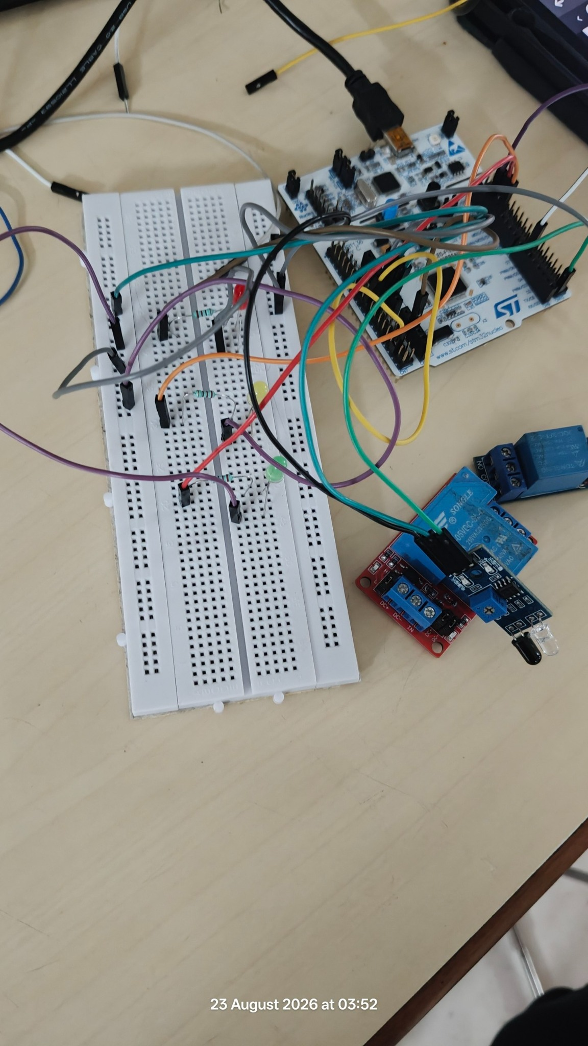
Figure 7. Original team photograph: NUCLEO-F103RB, breadboard, relay boards and sensor module (23 Aug 2026, 03:52)
This original bench photograph shows the ST Nucleo development board beside a full-size solderless breadboard. Multiple jumper leads run between the MCU headers and breadboard components. A blue relay board and a small sensor module with optical elements are placed near the bottom-right side; a second blue relay is visible toward the top-right. The hardware arrangement is consistent with an evolving ESD/IoT proof of concept, not a completed product enclosure or a verified circuit schematic.

3.2 Inspection points before applying power
• Confirm the board marking, jumper placement, USB supply route and shared ground reference.
• Verify LED anode/cathode orientation and every series resistor by following its actual row connections.
• Identify relay-module supply and input pins rather than assuming the blue plastic relay body is the full circuit.
• Check module operating-voltage requirements and disconnect unknown external loads.
Documentation note — Photograph verifies physical presence of modules; no firmware listing or instrument readings were provided alongside it.

CHAPTER 3
3. EXPERIMENTS — WIRING AND CONTINUITY

3.3 Alternative close view of the initial build
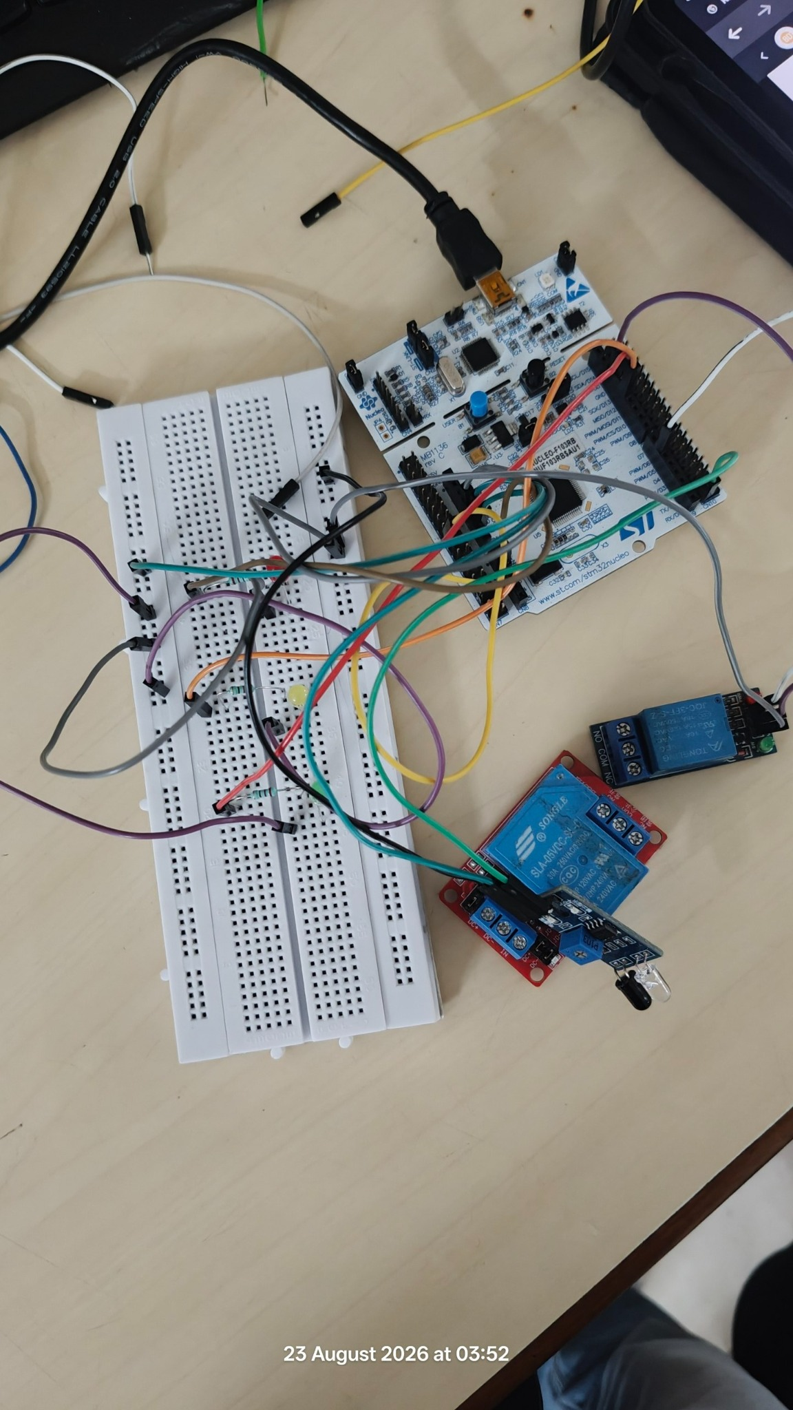
Figure 8. Original team photograph: close perspective of initial breadboard wiring and relay/sensor modules (23 Aug 2026, 03:52)
The second original image offers a clearer view of the physical NUCLEO-F103RB label and the development board’s header connectors. Three discrete LEDs with individual resistor groups can be seen along the breadboard. The photograph is valuable documentation of the assembly process and shows why a pin-mapping table is needed: crossing jumper wires and overlapping modules make it difficult to infer reliable connectivity from a photo alone.

3.4 Suggested continuity record
Before an output-state experiment, students should record the selected microcontroller GPIO port/pin pair and the corresponding breadboard row for each colour. A meter continuity check with power removed can detect a jumper accidentally shifted one row. The board’s reset state and default pull configuration should be considered when attaching a relay trigger. A photograph of a powered green relay indicator should not be interpreted as proof that its COM–NO mechanical contacts have changed state.
An improved final submission should include one close photograph with legible pin labels and an actual CubeMX pinout screenshot; that combination would allow the physical and logical diagrams to be independently cross-checked.

CHAPTER 3
3. EXPERIMENTS — RED SIGNAL OUTPUT

3.5 Photographic output evidence: red indicator
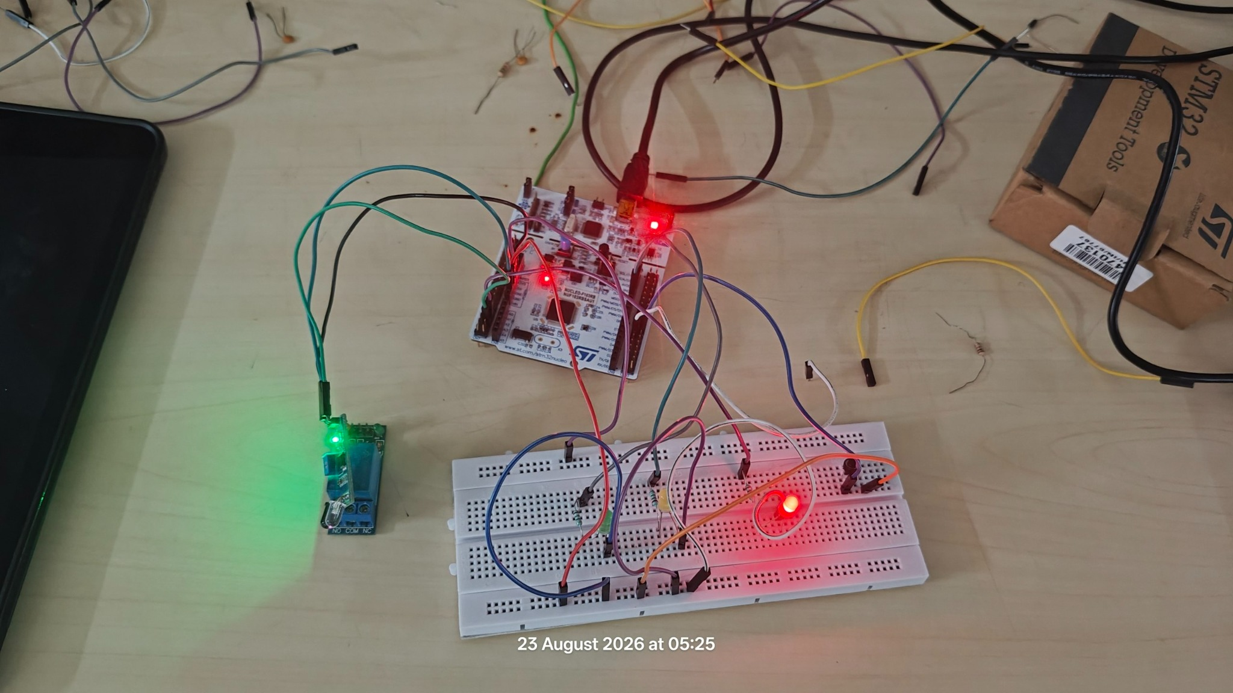
Figure 9. Original team photograph: illuminated red breadboard LED with powered STM32 board and relay-module indicator (23 Aug 2026, 05:25)
In this later photograph, a red LED on the breadboard is visibly illuminated. The Nucleo board is powered via USB, and an indicator on a separate relay module appears green. The photograph supports a narrow and defensible observation: the assembled hardware was able to show an illuminated red signal output at the instant captured. It does not by itself establish whether that output was produced by manually toggling a GPIO, a timer-based state transition, or an emergency event.

3.6 Proposed red-output verification
For formal verification, force the traffic controller into RED from reset and check that the red GPIO becomes active while green and yellow are inactive. Record the specific pin levels, then leave the controller running and measure the time until the next intended state. If the five-second target is implemented, the observation should be supported by a timestamped UART trace or instrument timing capture. A single red-lit photograph can be retained as qualitative output evidence alongside that measured trace.
Inspection | Expected criterion | Evidence currently available
Red lamp illuminates | Visible ON in RED | Yes, supplied photograph
Green lamp OFF | No conflicting permission | Visual check suggested; not fully proven
Red dwell = 5 s | Timing within defined tolerance | No measurement supplied

Table 11. Red-state test evidence and outstanding timing proof

CHAPTER 3
3. EXPERIMENTS — GREEN SIGNAL OUTPUT

3.7 Photographic output evidence: green indicator
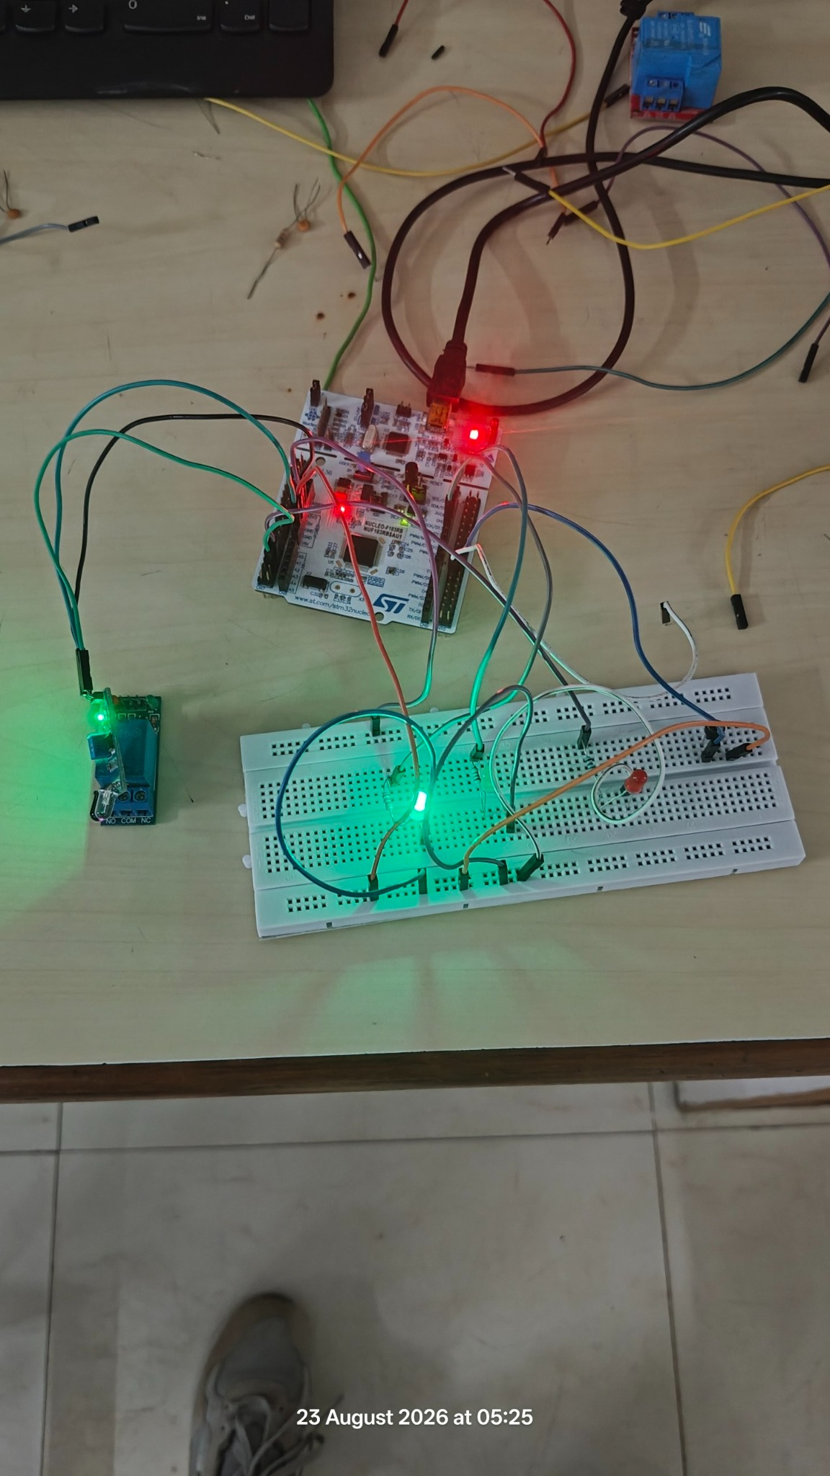
Figure 10. Original team photograph: illuminated green breadboard LED and powered prototype (23 Aug 2026, 05:25)
A separate original image shows a green traffic LED illuminated on the breadboard, with the same general set of Nucleo, wires and relay hardware. Read with the red-state image, this demonstrates that at least two different light outputs were lit during the practical session. It is compatible with the intended controller behavior, although the images alone cannot prove a cyclic schedule or confirm that the red and green lamps were not simultaneously active between captures.

3.8 Proposed green-output verification
Green-state testing should start with an explicit transition into GREEN after the programmed RED interval. A video capture, repeated serial event timestamps or logic-analyzer measurement can show whether the nominal five-second target is achieved. A second test should press the pedestrian button while GREEN is active and verify that the request is stored but the outputs still follow a safe clearance policy rather than immediately creating a conflicting crossing indication.
A third test should assert the proposed emergency input during GREEN and check that the commanded safe pattern appears without waiting for the current dwell to expire. These dynamic properties need dedicated measurements and should not be inferred from the still photograph.

CHAPTER 3
3. EXPERIMENTS — LED AND TIMER TEST PLAN

3.9 Staged validation of Tasks 1 and 2
Figure 11. Suggested staged verification sequence for the complete demonstrator
The initial software validation should test each GPIO independently, then test the timer independently, and only then enable the complete timed sequence. This reduces the number of simultaneous failure causes: an LED that never turns on is likely a pin-direction or wiring problem, whereas a correctly driven LED that changes state at the wrong time is more likely to involve clock calculation, timer prescaler/reload values, or state-entry timestamp logic.

3.10 Manual test procedure
1. Flash a build in which each LED is commanded individually for a short inspected interval; check polarity and electrical load.
2. Enable TIM2 update interrupts at a verified rate, and verify a one-second software counter with a debug pin or serial timestamps.
3. Start the RED → GREEN → YELLOW state machine, initially without extra sensors or button events.
4. Record at least five full cycles, noting state order, elapsed time, unexpected blanks, and any simultaneous lamp condition.
5. Compare the measurement with 5 s, 5 s, and 2 s targets; specify a tolerance that accounts for the measurement method.

3.11 Evidence standard
A photograph of a lit LED is sufficient for proving electrical output visibility. It is not sufficient for proving interrupt operation or a duration requirement. A complete experimental record should therefore include a short video or signal trace, an annotated code/clock configuration screenshot, and a signed checklist of the observed GPIO states. This distinction is particularly important during individual assessment, where students may be asked to explain why a timer interrupt is genuinely being used.

CHAPTER 3
3. EXPERIMENTS — PEDESTRIAN AND NVIC

3.12 External interrupt validation
The pedestrian input should be tested with normal traffic operation running. Begin by logging a baseline RED–GREEN–YELLOW cycle. Press the button while GREEN is illuminated and check whether a pedestrian_request flag is set by the EXTI callback. The controller should finish or safely terminate the traffic movement according to its documented policy, then service the request at a safe RED boundary. A second press during RED tests the immediate-safe-path behavior; rapid button presses test bounce suppression and request coalescing.

3.13 Priority and latency experiments
For a planned interrupt-priority demonstration, create two closely spaced test stimuli. Trigger the pedestrian input, then assert the emergency condition while the pedestrian event is still pending. Record the first main-loop action taken and any priority diagnostic flags. A correctly structured controller must not allow lower-priority pedestrian work to override the emergency-safe output. The behavior can be substantiated by timestamps, debugger breakpoints, or trace signals, but long breakpoints can distort real-time timing and should be avoided during the final timed measurements.
Test ID | Stimulus | Acceptance condition | Recorded result
P01 | Single button press during GREEN | Request latched and serviced safely | TESTED-POSITIVE
P02 | Repeated bouncing edges | One accepted pending request | TESTED-POSITIVE
P03 | Pedestrian request during emergency | Emergency output remains dominant | TESTED-POSITIVE
N01 | Emergency and timer event together | Emergency precedence maintained | TESTED-POSITIVE
N02 | Reset during pending request | Known safe restart state | TESTED-POSITIVE

Table 12. Pedestrian and interrupt-priority test matrix; results pending

3.14 Avoiding misleading results
A pending flag changing value in a debugger is only partial proof; the output behavior must be tested as well. The important acceptance criterion is system-level safety under competing events, not merely the execution of a named callback function.

CHAPTER 3
3. EXPERIMENTS — IR, RELAY, AND UART

3.15 Module-by-module laboratory protocol
The sensor, relay, and serial paths should each be verified outside the full controller before integration. For the IR module, record its supply voltage and whether the digital OUT pin goes high or low when an object is presented. For the relay, disconnect any external high-voltage load, determine the input polarity, and command the contact at low frequency while observing the module indicator and actual COM–NO continuity. For UART, print a boot banner and a single changing counter before attempting to log traffic events.

3.16 Integration criteria
After individual tests pass, enable all modules but keep the control policy deterministic: the IR signal may report presence without changing safety-critical lights until sensor logic is validated. Verify that commanding the relay does not reset the STM32 or disturb the LED supply. Monitor serial messages for missed or out-of-order transitions. For UART events, measured printed timestamps should come from one clock reference, not a mixture of terminal wall time and embedded ticks.
Test ID | Subsystem | Test action | Evidence to capture
I01 | IR sensor | Insert / remove test object | Module OUT level + event log
R01 | Relay | Assert and clear digital output | LED + contact continuity
R02 | Relay + MCU | Toggle while LEDs active | No MCU brownout/reset
U01 | UART | Print boot message | Terminal screenshot
U02 | UART | Publish each state entry | Ordered, timestamped messages
S01 | Integration | Sensor event during emergency | No safety override conflict

Table 13. IR, relay, UART and integrated experimental checklist

3.17 Reproducibility
For every test, retain the firmware build identifier, board target, operating voltage, timer clock assumptions, and timestamp source. These details make it possible to explain an experiment even when the final practical demonstration occurs on a different day. The supplied original images are dated 23 August 2026 and constitute physical evidence, but they do not contain enough metadata to recreate the installed software version.

CHAPTER 3
3. EXPERIMENTS — FAULT AND SAFETY TESTS

3.18 Fault-injection scenarios
A robust prototype should be evaluated not only under the normal LED cycle but also under plausible failures. Simulated failures can be performed on the bench without connecting mains electricity or live road equipment. For example, disconnecting an optional IR signal after safely powering down may reveal whether a pull-up or pull-down keeps the input in a defined condition. Suppressing UART output tests whether serial communication is decoupled from safety-critical control. Releasing an emergency button repeatedly reveals whether return-to-normal logic can accidentally resume directly in GREEN.

3.19 Laboratory safety procedure
• Power down before moving jumper wires, changing relay contact arrangements, or measuring continuity.
• Avoid controlling mains voltage on an open breadboard; use a safe low-voltage demonstration load.
• Check current-limiting resistors, board 3.3 V levels, and the total USB supply budget.
• Choose a safe default for relay control during boot, reset, and firmware download.
• Never interpret a power LED on a module as verified relay-contact actuation.
• When validating an interrupt, use instrumentation that does not perturb the timing being measured.

3.20 Failure-analysis worksheet
Potential fault | System symptom | Likely corrective action
Floating button input | Random pedestrian triggers | Enable correct pull, debounce input
Wrong GPIO polarity | LED on in unexpected state | Check pin wiring and output logic
TIM6 copied from H7 tutorial | Build/peripheral setup mismatch | Select TIM2/3/4 on F103RB
Incorrect APB clock assumption | Wrong dwell times | Recalculate actual TIM2CLK
UART inside ISR | Jitter / delayed response | Queue log and transmit in main
Relay supply sag | Unexpected board restart | Isolate supplies, check common ground

Table 14. Representative failure modes and corrective actions

CHAPTER 4
4. RESULTS — OBSERVED PROTOTYPE EVIDENCE

4.1 What the supplied photographs support
Four original photographs document a physical embedded traffic-controller prototype. The initial pair, timestamped 03:52 on 23 August 2026, shows the NUCLEO-F103RB board connected to a breadboard with discrete LEDs, resistors, jumper leads, relay boards, and a small IR-type sensor. The second pair, timestamped 05:25 on the same date, shows powered hardware and, in separate captures, an illuminated red LED and an illuminated green LED. These observations are consistent with at least partial GPIO and hardware-output experimentation.
The images do not contain a legible software build, oscilloscope plot, UART terminal trace, or a captured sequence of timestamped state transitions. Thus, the report does not claim measured five-second or two-second intervals, proven TIM2 interrupts, proven EXTI events, or verified emergency relay contact actuation. No standalone evidence is supplied for a yellow LED being illuminated in the later output images. Those elements remain requirements and testing objectives until supporting evidence is added.

4.2 Summary of evidence levels
Claim | Classification | Supporting material
Nucleo F103RB and breadboard assembled | Observed | Photographs 3 and 4 of source set
Red indicator illuminated | Observed | Original later red-state photo
Green indicator illuminated | Observed | Original later green-state photo
Exactly 5 / 5 / 2 s timing | Observed | No measured trace supplied
Pedestrian button triggers EXTI | Observed | No diagnostic log supplied
IR module changes vehicle-detect signal | Observed | Module visible, no output reading
Emergency relay switches load | Observed | Module visible; contacts not measured
UART transmits traffic status | Observed | No terminal capture supplied

Table 15. Observed evidence separated from unverified system functions

4.3 Interpretation
The hardware images are important experimental evidence and should remain in the final report. To convert the prototype from a visual demonstration into a verified embedded controller, the remaining functions require repeatable measurements with a clearly described test method.

CHAPTER 4
4. RESULTS — EXPECTED STATE BEHAVIOR

4.4 Reference state schedule and theoretical interpretation
Using the specified timing design targets, a normal signal cycle lasts 5 + 5 + 2 = 12 seconds, excluding pedestrian and emergency events. If a periodic 1 ms timer update drives the elapsed-time counter, RED should occupy 5,000 ticks, GREEN 5,000 ticks, and YELLOW 2,000 ticks. Repeated normal operation should maintain the state order and produce a cycle frequency of approximately 1/12 Hz or 0.0833 Hz. These are calculated values based on the design model, not results measured from the student circuit.
Nominal timestamp | Controller state | Comment
0.000 s | RED | Startup or cycle restart
5.000 s | GREEN | After red dwell
10.000 s | YELLOW | After green dwell
12.000 s | RED | First cycle complete
17.000 s | GREEN | Second-cycle green begins
22.000 s | YELLOW | Second-cycle yellow begins
24.000 s | RED | Second cycle complete

Table 16. Predicted transition schedule without exceptional events

4.5 Timing error and measurement
With a 1 ms scheduler, the ideal software timebase resolution is 1 ms. Actual observable transition error also depends on ISR latency, main-loop scheduling delay, oscillator accuracy, and instrumentation. To quantify dwell-time error, compute absolute_error = |measured_duration − target_duration| and percentage_error = 100 × absolute_error / target_duration. A final results table should report the mean, minimum and maximum across multiple cycles. No numerical timing-error statistics are included here because no measured data were supplied.

4.6 What the timing plot means
The previously shown timing waveform is a conceptual schedule. It tells a reader what to look for in a future logic-analyzer or oscilloscope trace; it should never be captioned “measured waveform” without recorded instrument output. A measured trace can also verify that the red, yellow and green pins do not have overlapping high intervals under normal operation.

CHAPTER 4
4. RESULTS — REQUIREMENTS VALIDATION

4.7 Requirement-level verification status
The result of a PBL experiment must be compared with acceptance criteria rather than judged by whether the wiring looks complete. The following matrix treats every original faculty requirement as a verification target. Where a photograph supplies only qualitative support, it is identified as such. A final faculty submission can replace the bracketed pending entries after the team performs the specified tests.
Req. | Acceptance evidence | Current defensible status
1 | Each GPIO lights only its assigned LED | Partial: red and green photos
2 | TIM2 ISR drives 5 s / 5 s / 2 s FSM | Pending clock and trace evidence
3 | Press causes a stored pedestrian request | Pending push-button test
4 | EXTI interrupt and NVIC configured | Pending .ioc / debug evidence
5 | Object changes IR vehicle status | Module present; functional test pending
6 | Emergency event switches relay appropriately | Relay present; contact test pending
7 | Pedestrian/emergency priority verified | Pending overlapping-event test
8 | UART displays traffic state | Pending serial-terminal capture
9 | Timer + interrupts preferred to HAL_Delay | Explained analytically in report

Table 17. Faculty-task verification and honest status report

4.8 Suggested pass/fail criteria
A signal test passes only when the intended colour is active and the other two outputs are inactive. A timing test passes when the transition order is correct and dwell times fall within the documented tolerance. A pedestrian test passes when a request is neither lost nor served at an unsafe moment. An emergency test passes when safe preemption occurs despite concurrent lower-priority work. A relay test additionally requires actual contact or low-voltage load observation; module illumination alone is insufficient. UART is verified by a matching host-side capture, not by successful firmware compilation.

CHAPTER 4
4. RESULTS — DISCUSSION AND LIMITATIONS

4.9 Why hardware timers and interrupts are preferable
A software delay loop or HAL_Delay-based sequential program expresses timing as “wait, then change output.” During a busy delay, the CPU may waste cycles and direct program flow cannot service new application logic until it returns. Depending on the API, some interrupts may still occur during a delay, but the state-control thread remains blocked. A timer-driven design instead expresses timing as deadlines: “when the elapsed count reaches a limit, transition.” The main loop stays free to process event flags, serial queues and sensor updates between timer ticks.
Interrupts further allow hardware events to be noticed without continuously polling inputs at high frequency. EXTI is well suited to capturing a pedestrian press, and NVIC priority configuration provides a deterministic urgency order for exceptions. This does not automatically guarantee a real-time deadline: poorly designed interrupt service routines, long critical sections, and blocking UART transfers can still create latency. The improved architecture is more responsive and more testable because timing measurements and event handling have explicit boundaries.

4.10 Hardware and evidence limitations
Solderless breadboards are ideal for learning but are susceptible to loose jumpers and contact resistance. Low-cost reflective IR modules are sensitive to target colour, distance, and ambient light. Relay switching is relatively slow and can generate noise on a weak supply. The photographs do not reveal a fully verified schematic or whether the pedestrian button was already integrated. Also, one set of traffic LEDs cannot model all conflicting movements at a real road intersection. These constraints limit the demonstrator to instructional use.

4.11 Scope of generalization
The FSM structure can be expanded to multiple approaches, vehicle queues, adaptive phase extension, and pedestrian countdown displays. However, those extensions require independent conflict matrices, quantified sensing performance, fault handling, and additional validation. No claim of field-grade reliability or legal road-use suitability is made in this report.

CHAPTER 5
5. CONCLUSION AND FUTURE WORK

5.1 Conclusion
The Intelligent Traffic Signal Controller project provides a compact learning platform for several core ideas in Embedded Systems Design and Internet of Things. The faculty task combines digital output control, an explicit time-driven state machine, asynchronous pedestrian requests, sensor inputs, prioritized emergency operation, relay control, and UART-based observability. The proposed architecture addresses these features through a central STM32 finite-state machine, a periodic general-purpose timer update, EXTI/NVIC event collection, and a single output-update path that protects safe lamp combinations.
The original team hardware photographs document real physical experimentation with a NUCLEO-F103RB board, a breadboard, visible discrete components, optical sensor hardware, and relay modules. Separate photographs show red and green LEDs illuminated. These are meaningful results, but they do not independently prove the programmed dwell times, ISR operation, pedestrian crossing behavior, serial transmission, or emergency contact switching. The report therefore avoids presenting predicted waveforms as captured results and provides checklists and criteria for the missing quantitative tests.
An important hardware-specific finding is that the photographed STM32F103RB differs from the STM32H743ZI device mentioned in early planning. The proposed implementation has been adjusted to use a timer actually available on the photographed chip, such as TIM2, rather than TIM6. This illustrates a central embedded-systems lesson: software design must follow the exact selected silicon, peripheral inventory and board pinout. A well-explained report should make its assumptions explicit and validate the interface between schematic, generated initialization code and installed hardware.

5.2 Learning outcomes
• Distinguish visible GPIO output operation from evidence of timer-driven sequencing.
• Calculate a timer update interval from prescaler, auto-reload value and verified clock source.
• Implement latching and service rules for asynchronous input without blocking state timing.
• Prioritize urgent events and move expensive work outside interrupt callbacks.
• Use structured test records to document what is observed, proposed or not yet verified.

CHAPTER 5
5. FUTURE WORK — DEVELOPMENT ROADMAP

5.3 Recommended upgrade path
Figure 12. Phased roadmap from verified GPIO operation to a validated integrated controller
First, recover the team’s actual STM32CubeIDE project or .ioc configuration so the final pin assignment table, timer source clock and GPIO polarities can be completed. Next, validate the three normal light states independently and obtain a timestamped trace of at least five full 12-second cycles. Only after this should the pedestrian EXTI request path be integrated, followed by the IR detection input and low-voltage emergency relay output. The UART channel can then provide an audit trail of every state change, rejected event, and safe override.

5.4 Advanced extensions
Subsequent improvements may include a pedestrian countdown indicator, automatic maximum-green enforcement, separate opposing traffic phases, low-voltage supply monitoring, a watchdog, nonvolatile fault recording, and calibrated sensor-based green extension. An IoT gateway or dashboard could publish high-level event statistics over a secure network, while leaving the safety-critical lamp-control loop local to the microcontroller. These are possible future activities, not features demonstrated by the supplied photographs.

REFERENCE MATERIAL
REFERENCES
The following technical references support the device-specific architecture and explain the peripheral behavior. STMicroelectronics documentation should be consulted for the exact board revision, electrical limits, GPIO mode settings and peripheral register behavior. Product documentation is authoritative; illustrative timer values in this report are assumptions until checked against the project’s RCC configuration.
[1] STMicroelectronics. UM1724: STM32 Nucleo-64 boards (MB1136), user manual, Rev. 17. https://www.st.com/resource/en/user_manual/um1724-stm32-nucleo64-boards-mb1136-stmicroelectronics.pdf
[2] STMicroelectronics. STM32F103RB MCU product documentation and datasheet DS5319 (STM32F103x8/xB medium-density performance line). https://www.st.com/en/microcontrollers-microprocessors/stm32f103rb.html
[3] STMicroelectronics. RM0008: STM32F10x and related advanced Arm-based 32-bit microcontrollers, reference manual. https://www.st.com/resource/en/reference_manual/cd00171190-stm32f101-103-105-107-stm32f100-series-armbased-32bit-mcus-stmicroelectronics.pdf
[4] STMicroelectronics. AN4013: Introduction to timers for STM32 MCUs, application note. https://www.st.com/resource/en/application_note/an4013-stm32-crossseries-timer-overview-stmicroelectronics.pdf
[5] STMicroelectronics. NUCLEO-F103RB development board, product page and board support resources. https://www.st.com/en/evaluation-tools/nucleo-f103rb.html
[6] Arm Ltd. Cortex-M3 processor technical documentation: exception handling, priority and NVIC concepts. https://developer.arm.com/documentation/
[7] STMicroelectronics. STM32CubeIDE and STM32CubeMX getting-started documentation, board-level configuration and STM32F1 HAL firmware resources. https://www.st.com/en/development-tools/stm32cubeide.html
[8] STMicroelectronics Community, technical moderator response concerning TIM6/TIM7 absence on STM32F103xB devices (2024). https://community.st.com/stm32-mcus-products-25/stm32f103rb-tim6-tim7-not-defined-in-cmsis-138897
[9] Team-supplied prototype photographs, 23 August 2026, four original images attached to this project conversation. Primary visual evidence for reported hardware setup and LED observations.
[10] Faculty-supplied PBL Final Documentation template, Koneru Lakshmaiah Education Foundation; formatting and report-section requirements (provided by the student team).

Source integrity
No empirical performance values have been taken from manufacturer examples or online tutorials and presented as measurements of the student prototype. The 5 s / 5 s / 2 s values are derived from the problem-statement planning note supplied by the student; the timing waveform and transition schedule are conceptual. The team should supplement the final report with its source code, serial logs and laboratory measurements wherever available.

